Shayan Taheri --- Full Custom VLSI Design --- Final Project Report

Introduction

In this project, a synchronized 16-bit carry-select adder is designed and implemented at schematic- and layout-level. The adder circuit is broken to multiple modules for the purpose of simplification. Each module is implemented separately and then all are connected to each other to build the whole adder architecture. The implementation along with the functional verification are done using the Cadence “Front to Back Design Environment” (a.k.a. Virtuoso). The design implementation has the power of 50.85 mW, area of 4565779.245 μ$m^{2}$, and clock period of 5.797 ns.

Digital Cells Design, and Implementation at Schematic and Layout Levels

In the traditional adders, the sum of each bit position is added and the generated carry is propagated into the next position. The propagated carry reduces the speed of addition. The carry select adder can be used to alleviate this problem by speculative and parallel calculation of partial sums and carries. Adding two n-bit numbers with a carry-select adder is done with two adders (therefore two ripple carry adders) in order to perform the calculation twice, one time with the assumption of the carry-in being zero and the other assuming it will be one. After the two results are calculated, the correct sum, as well as the correct carry-out, is then selected with the multiplexer once the correct carry-in is known. In this way, the adding operation delay (587.693 ps) is reduced to the multiplexing operation delay (~125 ps). The ideal number of full-adder elements per block is equal to the square root of the number of bits being added, since that will yield an equal number of MUX delays. Figure 1 shows an optimal 16-bit carry select adder with block sizes of 2-2-3-4-5. The total delay equals to two full adder delays, and four mux delays.

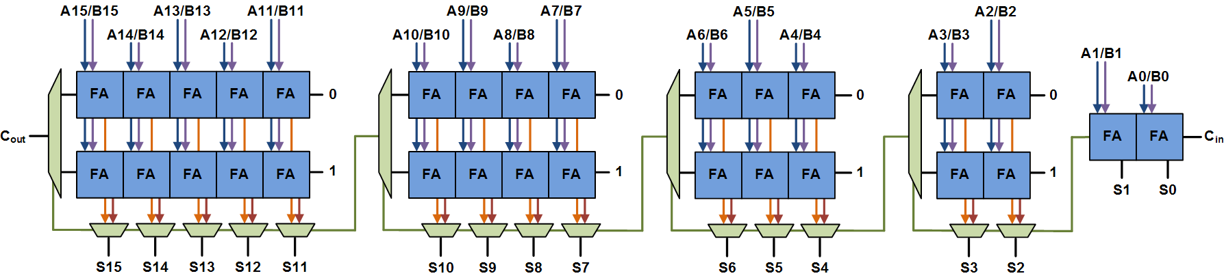
Figure 1: The 16-bit carry select adder architecture

In this implementation, this architecture is broken to four main modules that are: (1) 2-Bit FA, which is the two-bit full adder for A<1:0>, B<1:0>, and S<1:0> signals; (2) FA_Sub, which is a 14-bit full adder for A<15:2> and B<15:2> signals and there are two versions of it for Cpredict = 0 and Cpredict = 1; (3) Mux_Sub, which is an array of multiplexers for S<15:2>, Cstages<3:1>, and Cout signals and there are 18 multiplexers in this array; and (4) DFF Array, which is an array of D flip-flops for Ai<15:0>, Bi<15:0>, Ci, So<15:0>, and Co signals and there are 50 D flip-flops in this array. Each module is implemented and tested independently to make sure that it works and then they are all connected to construct the whole architecture. Also, a schematic-level test-bench circuit is built for the adder in order to find its energy and power. Figures 2 and 3 display the adder implementation at schematic- and layout-level respectively.
Figure 2: The 16-bit carry select adder schematic
Figure 3: The 16-bit carry select adder layout
In the transient simulation of the circuit, Ai<15:0> is set to ground (i.e. logic 0), Bi<15:0> is set to supply voltage (i.e. logic 1), and carry-in is considered as a pulse voltage signal with the amplitude of 5 V, delay of 18.5 ns, pulse width of 100 ns, period of 200 ns, and rise and fall times of 100 ps. The clock signal has the amplitude of 5 V, delay of 5 ns, pulse width of 4.5 ns, period of 9 ns, and rise and fall times of 100 ps. The duration time of the transient simulation is set to 50 ns that is shown in Figure 4. Although, a simulation is run for 15 ns only for its combinational circuit, shown in Figure 5.
Figure 4: The functional simulation of the synchronized 16-bit carry select adder
Figure 5: The functional simulation of the combinational 16-bit carry select adder
The timing and the current analyses of the synchronized 16-bit carry select adder are shown in Figures 6 and 7.
Figure 6: The current analysis of the synchronized 16-bit carry select adder
Figure 7: The timing analysis of the synchronized 16-bit carry select adder

The numeric results of the circuit analyses are shown in the following tables.

Cout Rise Time  ($Cout- t_{r}$) | Cout Fall Time  (${Cout- t}_{f}$) | S<15> Rise Time  ($S<15>- t_{r}$) | S<15> Fall Time  (${S<15>- t}_{f}$) | Propagation Delay for Cout | Propagation Delay for S<15>
$$104.9 ps$$ | $$128.4 ps$$ | $$193.7 ps$$ | $$187.6 ps$$ | $$3.864 ns$$ | $$3.9755 ns$$

Table 1: The timing analysis results of the combinational circuit

Propagation Delay for Cout | Propagation Delay for S<15> | Average Power | Energy Per Switching Event | Cell Height | Cell Width | Cell Area
$$5.583 ns$$ | $$5.797 ns$$ | $$50.85 mW$$ | $$2.5425 nj$$ | $$1702.95 μm$$ | $$2681.1 μm$$ | $$4565779.245 μm^{2}$$

Table 2: The synchronized 16-bit carry select adder information

Conclusion

A synchronized 16-bit carry-select adder is designed and implemented at schematic- and layout-level in this final project. The adder circuit is broken to multiple modules for the purpose of simplification and more reliable testing and verification. In this way, a library of cells (e.g. an array of D flip-flops) is costructed that can be used in different designs. The design represents the power of 50.85 mW, area of 4565779.245 μ$m^{2}$, and clock period of 5.797 ns.

